Getting into GOOGLE CLASSROOM
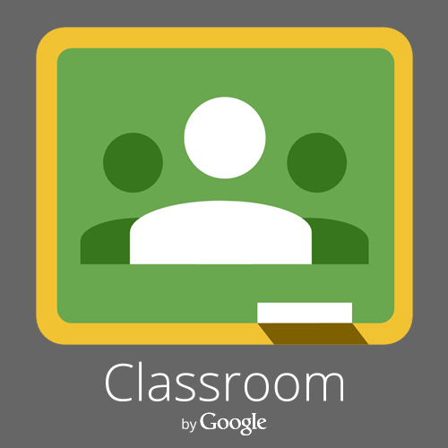
This Photo by Unknown Author is licensed under CC BY-NC-ND
Go to www.google.com
Click on the button in the top right-hand corner that says login.
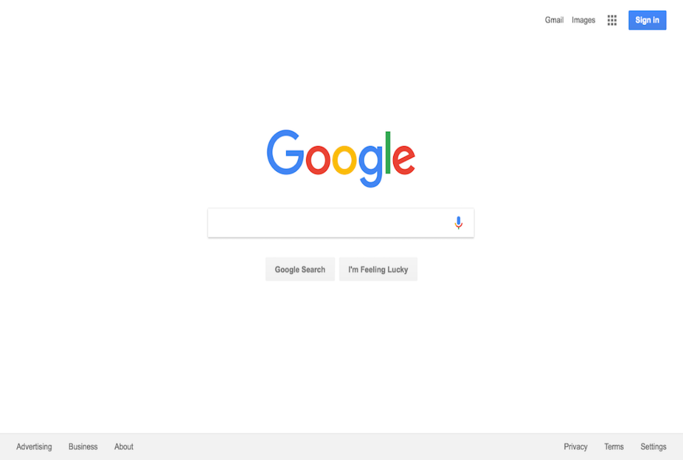
This Photo by Unknown Author is licensed under CC BY-SA
Student username is the first letter of their first name with their entire last name @students.wcpss.net
If you used this last year, you will use the same password. If it is your first time logging in, you will use your student id# printed inside your homework folder.

Next you will click on the series of dots in the top right-hand corner.

This Photo by Unknown Author is licensed under CC BY-SA
•••
•••
•••
These dots will link to google apps.
Click on the google classroom app.

Once there you will see a plus (+) sign. You will need the following codes to join the classes for each subject:

ELA isvhzqu

Mrs. Fisher, 5th Grade

This Photo by Unknown Author is licensed under CC BY-NC-ND

Google Classroom Code
ELA isvhzqu

